HEP Reconstruction and Analysis Software for Exascale-Era Computing:

Final Report (Phase II Deliverable)

  - Chris Green (FNAL)
  - Marc Paterno (FNAL)
  - Dana Robinson (The HDF Group)
  - September 29, 2017

Introduction

A long-term objective at Fermilab is to produce a prototype software system suitable for moving HEP experiment event data through multiple processing stages in an exascale-class computing facility. In particular, work will concentrate on demonstration of two critical components of a complete event-processing system: (a) high-performance I/O to a parallel filesystem, and (b) communication of event data through high-performance node interconnects (rather than through the filesystem), between processes of one application running across hundreds or thousands of nodes - a distributed program.

The primary goals of this project are to advise, recommend, and provide the following:

1. Provide a plan to design a file schema using HDF5, suitable for the storage of experimental HEP data.

Experimental HEP data are typically richly structured (many nested types, not dominantly fundamental types), and are dominantly variable-size data structures (such as C++ vectors). Part of the project's research work is to understand, using real-world use cases from some of the experiments we currently support, how to use HDF5 most effectively to store the data. We have selected three specific use cases for this:

- Vector of MC Hit Collection
- Vector of MC Truth
- Assns

These were selected since they comprise a sampling of the range of complexity and data types that would need to be stored in HDF5.

2. Determination of what, if any modifications of the organization of HEP-specific data structures are needed.

The current software design practices in experimental HEP are heavily influenced by the technology (ROOT) that dominates the field. In this work, we investigated and recommend changes that would be appropriate in the design of our data structures to allow us to make better use of HDF5 and the high-performance parallel storage systems that it supports.

An important part of experimental HEP software development is the ability of physicists to invent new persistable data types, without the physicist needing a deep understanding of the I/O system, without having the physicist writing any code to support I/O for the new type, and without having to extend the event-processing software framework to know about the new type. In this work, we also discuss what might be necessary to allow both the C++ classes for data products and the I/O code to support those classes to be automatically generated.

Software Produced
As a part of this work, several software products were produced:
- An I/O library, written in C, which can construct HDF5 data structures for each of the selected data products as well as read and write data buffers representing the data product's data.
- Small C++ programs that transform the FNAL data products into buffers which are then written to an HDF5 file using the I/O library.
- Small C++ programs which compare the FNAL data products that have been constructed from Root storage with identical data products that have been constructed from HDF5 storage. These programs also include timing calls so the I/O can be profiled.
All software produced as a part of this work can be found at:

https://github.com/marcpaterno/hdf5_art_explore

The I/O library is located in the h5fnal subdirectory. The C++ programs are located in the root_hdf5_io subdirectory. The writers are named '<product>_writer.cc' and the compare programs are named '<product>_compare.cc'.

Instructions for building and using the software are included in the repository.

Modeling of Data Products in HDF5

Events, Runs, and Overall File Structure
Figure 1 - Data organization 'by event', where each event's data products are stored in a containing group.
In the prototype HDF5-based HEP data model we created, each HDF5 file is intended to hold the same data as a corresponding ROOT file. Runs, sub-runs, and events are each modeled using a group as this was the most straightforward and obvious implementation. In each group, creation order is tracked so that iteration over the sub-groups can proceed using the most natural order for HEP data. Each data product is also stored in its own top-level data product group as a way of keeping multiple data products separated. All of these containing groups are given a name at creation time, which is supplied by the user and arbitrary, using any naming scheme the user wishes.

The idea of this scheme is to store data in per-event containers (figure 1), which mimics how the data are organized and processed in the FNAL code. An alternative data storage layout would be to flatten this structure at one of the higher levels, storing all the data for a given data product type in a single HDF5 product container and maintaining an associated 'index' dataset which would indicate which elements belong to a given event (figure 2). This would reduce the amount of internal HDF5 file metadata, making for smaller file sizes and fewer I/O calls, particularly when complex data products store a small number of data elements, but at the cost of a more complex mapping between FNAL HEP code and HDF5 storage.
Figure 2 – Data organization 'by data product', where there is only one copy of each data product and a separate index dataset gives the range of elements in each data product that belong to a given event.
In this work, each data product was stored in a separate file, but this was solely for convenience, and is not a feature of the data model. It is also worth noting that, unlike ROOT, HDF5 is not limited to having a single file open at a time. Current ROOT-based data processing generally uses a space-inefficient scheme where a copy of the input file is used to store the output of a processing step (A, in figure 3). Provenance concerns require all of these files to be archived. HDF5 can support the scheme outlined in A, but since the limitations on the number of open files is effectively determined by the OS and file system, independent data files can be stored at each step. If desired, an optional top-level index file (dashed lines) containing external links could also be used to present a single file to downstream software. It is entirely up to the user to decide how many files to create.

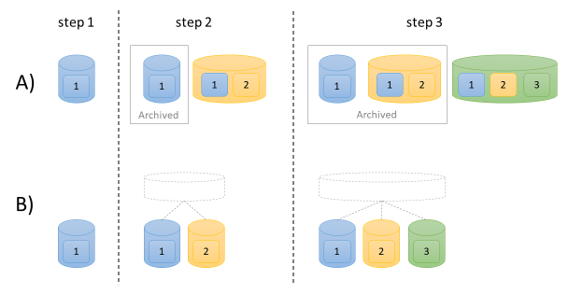
Figure 3- Data file organization through multiple steps. Each numbered box represents the data from a processing step and each cylinder represents a data file. Schemes A and B are explained in the text.

Data Products
Each data product was modeled using HDF5 datasets and attributes, which were stored in a top-level containing group to keep the HDF5 file objects for each data product isolated. In the depictions of each data product, ovals are used to represent HDF5 groups and rectangles represent HDF5 datasets. Rounded rectangles represent the attributes used in the Assns data product. Each data product can be given a user-defined, arbitrary name when it is created. This name is assigned to the top-level containing group.

Vector of MC Hit Collection
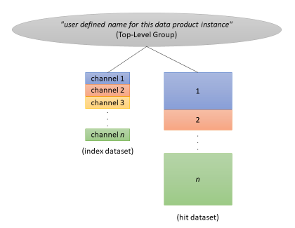

Figure 4 - The Vector of MCHitCollection data product organization in HDF5. Note that channel 3 is an empty hit collection and is associated with no hits in the second dataset..
The Vector of MC Hit Collection data product is modeled as two 1D datasets (figure 4). The first dataset contains the MCHit data. Hits from all hit collections in the vector are concatenated into a single dataset. A second dataset of compound type stores (channel, start, count) information which can be used to extract the hits associated with a channel which allows us to reconstruct the hit collection. Empty hit collections simply set the count for a particular channel to zero.

Vector of MC Truth
Figure 5 - The Vector of MCTruth data product organization in HDF5. The string dictionary is stored at a higher level and is not shown here.
The Vector of MC Truth data product is spread across multiple datasets (figure 5):

- A 'truths' dataset which stores an origin field, a neutrino dataset index, and particle dataset start and end indices.
- A 'neutrinos' dataset which stores MCNeutrino fields. Note that the MCParticle references are not directly stored but are regenerated when the neutrino is added to the truth.
- A 'particles' dataset which stores MCParticle fields as well as start/end indices into the trajectories and daughters datasets.
- A 'trajectories' dataset which stores MCTrajectory fields.
- A 'daughters' dataset of type integer which stores the Track ID of the corresponding particle.
- The Process and EndProcess strings are stored using an auxiliary string dictionary structure (discussed below).
In all the above datasets, setting a reference / dataset index to -1 represents 'none'.

Although this data product seems complicated, data serialization is straightforward. An MCTruth object is constructed by starting with an entry from the truths dataset, getting the corresponding neutrino and particle data using the stored indices, and then, for each particle, getting trajectory and daughter data using the stored indices.

Storing strings in HDF5 warrants some discussion, however. The Process and EndProcess strings in the MCParticle data product, for example, can be of variable length and are typically repeated throughout the data product and even throughout the file. Variable-length string data can be stored in HDF5 in a variety of ways (figure 6):

- Using an HDF5 variable-length type (A in figure 6). Unfortunately, variable-length data storage in HDF5 cannot be compressed and breaks locality by storing the actual data in a different location than the rest of the dataset's data.
- Fixed-length string types, where the length is chosen to balance the expected maximum length of the string and potential waste (B in figure 6). This has the disadvantage of wasting some space (though this wasted space is usually highly compressible) and imposing a maximum string length on the data values.
- A third way, and the one used in this work, is to concatenate the strings in a 1D character dataset and store begin/end indices for each string (C in figure 6).

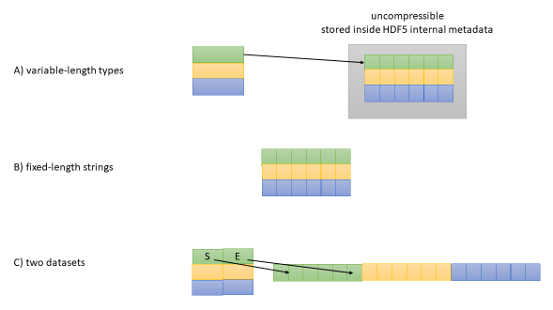
Figure 6 - Schemes for storing string data in HDF5.
In this project, we have gone one step further – since most of the strings are expected to be duplicates, we have created a string dictionary data structure in the HDF5 file. The dictionary is read from the disk (or constructed) at the beginning of I/O, kept in memory until it is no longer needed, and only unique strings are added to it. If the number of unique strings is low and number of references to the dictionary is high, this can save quite a bit of space. As a way of ensuring that that condition holds, a single dictionary was created in the root group of the HDF5 file and used for all MCParticles in the file.

Assns
Figure 7 - The Assns data product organization in HDF5.
Two 1D datasets are used to store the assns data (figure 7): An associations dataset, which stores the pairs of left and right process indexes, product indexes, and keys; and an optional data dataset, which stores associated data of arbitrary type. The names of the left and right data products are stored as fixed-length string attributes attached to the data product's top-level containing group. The type of the optional association data is set using an HDF5 type ID and the data are passed in and out via a void pointer.

Profiling
The two most important performance considerations for HDF5-based storage are: (1) The on-disk size of the stored data products, and (2) I/O speed. Both were measured for each data product using a representative DUNE file. The Vectors of MCTruth data products in this file were judged to be too simple (lacking even an MCNeutrino member), so we also profiled more complicated Vector of MCTruth data from a separate file ('reco truths' in the data tables).

The profiling system

Hardware
MacBook Pro (mid 2015)
macOS Sierra (10.12.6)
Intel Core i7, 4 cores @ 2.8 GHz
16 GB RAM
SSD hard drive (Journaled HFS+)

Virtual Machine
VMWare Fusion 8.5.8
64-bit Scientific Linux 7.3
16 GB RAM
4 processors
File system where code was run: XFS

Software (all via pullProducts)
dunetpc v06.38.00 / e14 / prof
gallery v1.03.12 / e14 / prof
HDF5 1.10.1a
gcc/g++ 6.3.0

On-Disk Size
On-disk size was measured differently for both ROOT- and HDF5-based storage. Since each HDF5 file stored a single data product, storage size was determined using the total file size. Root data sizes were determined using the FNAL product_sizes_dumper tool. Since the HDF5 data products measure the size of the entire file, they include the size of the file's superblock and the run, sub-run, etc. groups which are not included in the Root measurement. The size of this file infrastructure is assumed to be small relative to the size of the data products, however.

Results
 | hdf5 | root | Delta | % diff
assns | 623328 | 1022603 | -399275 | -39
hit collections | 202577099 | 259870057 | -57292958 | -22
truths | 440215 | 20905 | 419310 | 2006
reco truths | 70805 | 86633 | -15828 | -18
Figure 8 - Data product sizes (in bytes)

Discussion
In general, there appears to be a decrease in the size of the data products when stored in HDF5. The exception to this is the massive increase in size of the Vector of MCTruth data from the test file. This seems likely due to the uncomplicated data of low cardinality (typically only one particle per MCTruth) stored in that particular DUNE file. In this case, the overhead the five MCTruth datasets could be significantly greater than the data stored. In experimental setups where storing very small amounts of data in complicated data structures is common, a flattened, 'by data product', experimental structure like the one shown in figure 2 might be more appropriate. In that layout, the dataset overhead for the data product would only be incurred once instead of once per event. Judging by the more complicated reco truths data, HDF5 Vector of MCTruth data will begin to show decreases in file size once the number of elements stored in a dataset increases past a particular threshold.

When it comes to HDF5 data, there are many ways to decrease the file size and several of those were employed in the test code. All datasets were chunked, with the chunk size set to reasonable, though not carefully tuned, values. All datasets were also compressed using gzip compression (at compression level 6) and the shuffle filter, which groups the nth byte of each data element in the chunk. With certain data types and patterns, the shuffle filter tends to create long runs of identical bytes, which are very compressible. The groups which represented the sub-runs were also compressed since they contain many event names that follow a pattern, so compressibility should be good. Overall, though, it should be noted that only the crudest methods were used to reduce the file size and further improvements would almost certainly follow from some experimentation and tuning.

I/O Speed
I/O performance was measured by placing separate time calls around ROOT and HDF5 data product read calls in the C++ comparison programs. The C++ standard library's chrono API was used for this. The timed code encapsulates both reading the stored data from the disk and constructing the FNAL C++ objects. Each compare program was run four times, discarding the first one, and the average of the total data product processing time was reported.

Results
 | hdf5 | root | Delta | % diff
assns | 54301 | 163805 | -109504 | -67
hit collections | 2776254 | 3025097 | -248844 | -8
truths | 118871 | 6707 | 112164 | 1672
reco truths | 14182 | 5208 | 8974 | 172
Figure 9 – Total time to read all data products of a particular type across all events (microseconds).

Discussion
The Vector of MCHitCollection performance improvement over ROOT is modest and, given the smaller size of the HDF5 data, not altogether unsurprising for this straightforward data product. Under both HDF5 and ROOT, we expect the I/O to consist of reading sizeable amounts of data that are easy to map into MCHits and MCHitCollections.

The Assns data are a little harder to explain, with almost an order of magnitude speedup compared to the Vector of MCHitCollection, which seems similar in its simple storage layout. One potential problem is that the HDF5 code is unable to instantiate a Ptr() object due to the limitations of the Fermi code, so the HDF5 code skips this and we check for the equality of the HDF5 and ROOT Assns objects by comparing the other public fields instead of using the provided object equality operator. If this Ptr() construction is computationally expensive, this could explain some of the difference. Note also that representative DUNE file and Assns data product used for profiling did not make use of the 'extra' Assns data. I/O performance on that dataset would depend on the nature of that data (type, size, etc.).

The Vector of MCTruth I/O performance is significantly worse under HDF5. This is most likely explained by two factors. The first relates to the more complicated HDF5 implementation of the data product, as mentioned in the storage discussion, above. In the representative DUNE performance test file, each vectors contains only a single MCTruth element containing a single MCTrajectory, a single MCParticle, no MCNeutrino, and no daughters. Opening a Vector of MCTruth in HDF5 involves opening five datasets, and this overhead is large compared to the paucity of data stored in each one. Another consideration is ROOT caching. ROOT stores all instances of a particular data product together and, due to the small size of the data, is able to store the bulk of the Vector of MCTruth data in a few common ROOT baskets, which are cached after loading. As the Vectors of MCTruth grow in size, this advantage starts to decrease, as can be seen in the 'reco truths' data.

Notice the I/O speeds at the beginning of a typical run. Each row is the time in microseconds to process an event.

run 1
root | hdf5
3557 | 1787
19 | 1130
15 | 1137
14 | 1135

The very large ROOT read time for the first event is when the bulk of the Vector of MCTruth data are read and subsequent event processing simply fetches data out of the ROOT cache. Organizing the HDF5 events to be stored using a 'by data product' scheme as outlined in figure 2, would make I/O performance for this data product more of an apples-to-apples comparison.

Project Conclusions

HDF5 can effectively model HEP data in a straightforward way
All three representative data products were modeled in HDF5 and shown to produce identical C++ objects regardless of being read from ROOT or HDF5 storage. HDF5 can support both 'by event' and 'by data product' organization. Mappings between HEP data products and HDF5 storage were generally straightforward and two distinct file-wide organizational strategies were identified. No modifications of the HEP data product code were required and all HEP to HDF5 transformations took place using the public HEP APIs.

HDF5 storage sizes can be smaller than those of ROOT
Compressibility and storage efficiency can be at least as good as ROOT, particularly with respect to simpler data products that store a large number of elements. More thorough optimization could produce even smaller files.

HDF5 I/O performance can be better than ROOT
Read performance also seems to be at least as good as ROOT with respect to simpler data products that store a large number of elements. Further optimization could produce even faster I/O speeds.

Organizing HEP data by data product instead of by event may be necessary
When a data product that will only store a few elements has a complicated, multi-dataset implementation in HDF5, there will likely be performance and storage size benefits to the layout shown in figure 2. This will improve compressibility of the data and reduce HDF5 file object open and close churn.

Automatic generation of data product I/O code
Since no code or HEP-to-HDF5 data definition language was defined as a part of this work, only general ideas and observations can be made here. Two points immediately come to mind:

- It is possible to use a data-definition language to specify HDF5 file layout. Several formats for this already exist,.
- Mapping HEP data products to HDF5 involved straightforward use of one or more datasets, with references between datasets stored as simple integer indices. HDF5 datatype construction was similarly obvious. All software written as a part of this project was designed with obvious, more easily automated mappings between the HEP data products and HDF5 in mind.
Given these two things, and assuming that the data modeled in this project represent the expected level of complexity to be found in current and future HEP data products, it seems very likely that a DDL / markup system could be constructed that would allow a generator to automatically construct and fill datasets of a specified type. Researchers would probably need to understand that there are n-dimensional containers called 'datasets' that are of a particular type, but it should otherwise be possible to hide the mechanics of HDF5 under the hood so users would not need knowledge of the HDF5 API. Of course, highly efficient use of HDF5, either in I/O speed or data size, would probably require manual intervention. A tuner program could easily handle simple things like varying the chunk size and observing the effect on performance and data size, but complex data rearrangements would probably still have to be performed by humans.

Appendix: UML Diagrams

Vector of MCHitCollection
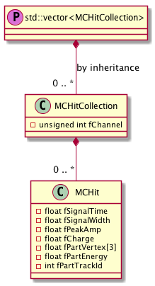

Vector of MCTruth
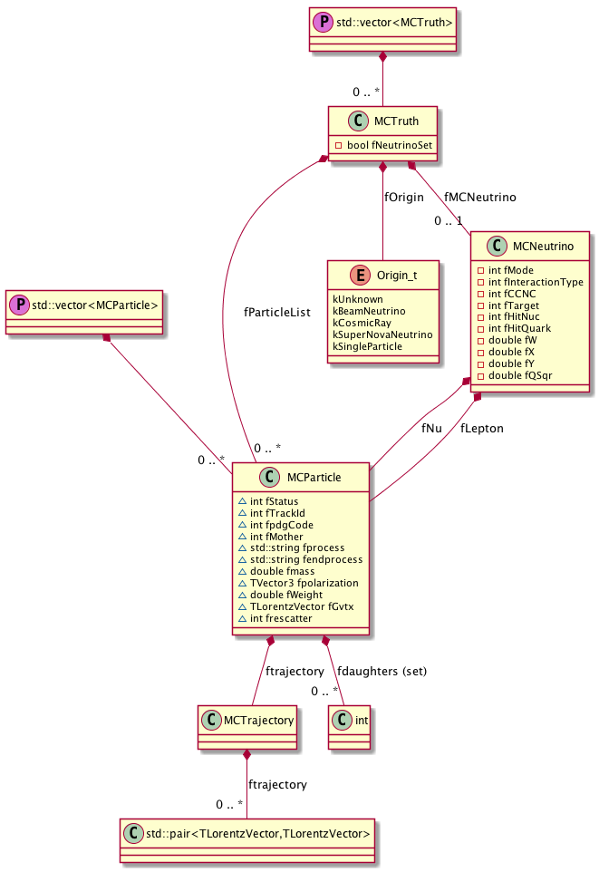

Assns
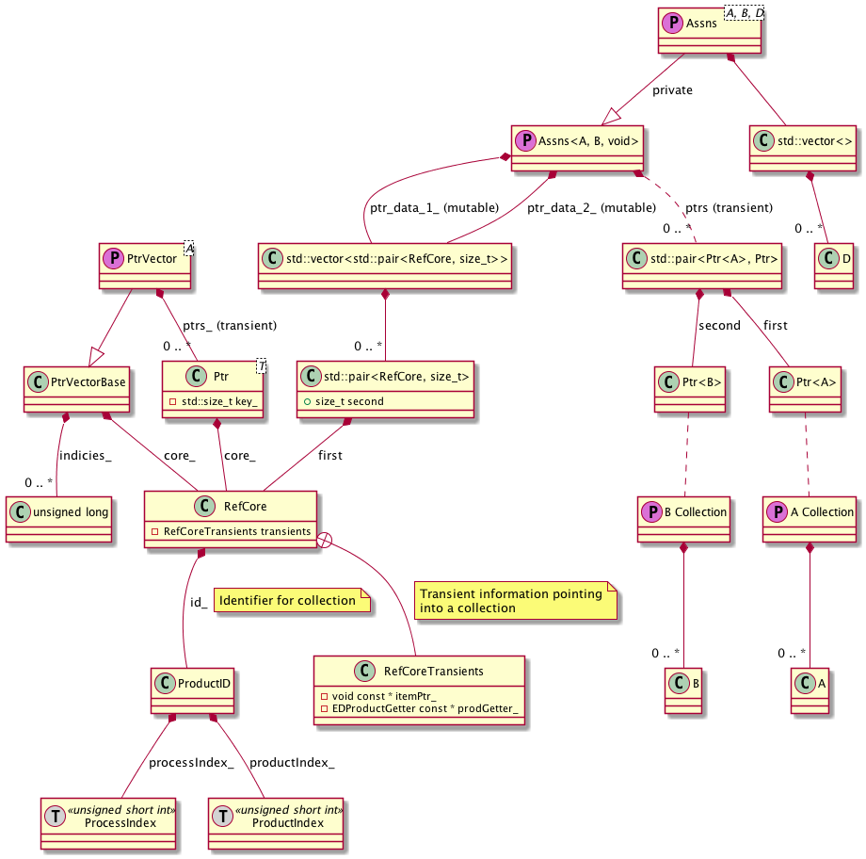

Technically, links are named in HDF5, not groups and datasets (a group is basically a collection of links), but the semantics are identical for our purposes here.
The string dictionary was implemented to demonstrate flexible string handling, to minimize I/O, and to avoid using variable-length HDF5 types. The implementation was done without constructing a hash table, though, so string lookups are not fast. In this project there were only two strings in the dictionary (the empty string and one process string), so this was probably not a concern, but this should be kept in mind when evaluating the performance data.
Though it should be noted that, due to the nature of the run/sub-run/event processing loop in the compare program, the HDF5 code opens and closes the three groups that represent them inside the timing code whereas the ROOT code does not perform equivalent work. It was assumed that this code would not significantly skew the results.
XML: https://support.hdfgroup.org/HDF5/XML/
DDL: https://support.hdfgroup.org/HDF5/doc/ddl.html

